Ethical Ministry Refresher:
Particular Relationships.
A continuing education program for: Ministers, Deacons, Candidates, Pastors, Chaplains, Pastoral Practitioners and Lay People engaged in ministry.

Acknowledgement
This program has been prepared by the UCA Synod of NSW/ACT and material is used with permission.
For further information please contact:
Rev Dr Morag Logan
Culture of Safety Manager
Morag.logan@victas.uca.org.au
(T) 9116 1434
Code of Ethics and Ministry Practice
and the:
Code of Conduct for Lay Leaders

The Ethical Ministry Refresher is an opportunity to gather ministry agents to engage with the Code of Ethics and Ministry Practice to:
- Exercise professional awareness,
- Encourage reflection on best ministry practice
- Promote collegiality, to build frameworks of support for future growth and change
… and a good excuse for a cuppa together. Ministers, Candidates, Pastors, Chaplains and Lay People engaged in ministry (including Lay Preachers) in the Synod of Victoria and Tasmania are required to attend two Code of Ethics workshops each year.

BEFORE THE SESSION
- Read through this document. It begins with the preparation work you will need to complete to attend this Code of Ethics session and is followed by the session outline.
- Ensure you have a current copy of the relevant Code of Ethics and Ministry Practice and bring it to the refresher session. You can find a copy of the Codes of Ethics here: UCA Code of Ethics (Updated 2025) | UCA Assembly
- Review the ‘Ground rules for Workshop discussions’ and ‘Safe shared pairing’ (below) and be ready to participate.
- Complete the preparation outlined in the next section.

PREPARE
Please read all of this document before the start of the session. The document includes: Guidelines for Group discussion; Paired Sharing Guidelines; Extracts the from the code of ethics and ministry pratice; a reflection resource and a set of case studies.
Please bring a full copy of your code of ethics and ministry practice to the session.
Please reflect on and prepare reflections on at least four of the case studies and ensure that you read all of them to be able to participate in group discussions well.

INTEGRITY – RESPECT – CONFIDENTIALITY
Guidelines for Group Discussion
- Arrive on time, remain for the entire session, and do not wander in and out of the session.
- Unless you’re expecting an emergency call, please turn mobile phones off. If you must take a call, please leave the room before doing so to minimise the interruption.
- Practice active listening. Hear what the other person is saying. Let them finish talking. Think before you respond. Try to ask a question for clarification rather than making an assumption.
- Talk about yourself and your own experience. You may ask questions of others, but do not challenge the validity of another’s personal experience or point of view. Code of Ethics case studies are intended as tools for reflecting on how the Code applies to our own ministry practice. Sometimes discussions may need to hold a wide range of views, and the facilitators may need to ensure the spirit and intention of the Code of Ethics is being upheld in the discourse.
- Keep your comments brief and to the point, so everyone has a chance to speak.
- Do not generalise the experience and feelings of others based on your experience. Let people speak for themselves.
- Do not attack, or try to hurt, or pass judgment on anyone, whether they are present or not.
- Treat this group session as confidential conversation; do not repeat elsewhere what is said during this session.
- Stay on topic.
- Please be discerning about what is appropriate for you to share in the wider group, what may be better suited to the ‘paired sharing’ and what should be shared only with your Supervisor.

Safe Paired Sharing
This is an opportunity to engage with the topic on a more personal level, and to integrate your experience as it relates to the Code of Ethics. Please keep discussions confidential and remember that paired sharing is in no way to take the place of a conversation with your Supervisor. We are all vulnerable people. Collegial respect and care for one another is essential for ministry.
Sharing an example from your ministry could include:
- An actual (de-identified) situation that you feel comfortable to discuss in this setting;
- A ‘hypothetical’ situation that could possibly happen to you or someone else – what steps would you take to resolve it, or how might you prevent a breach of the Code of Ethics? What choices might you make in this situation?
- A situation when you were concerned about another person’s ethical engagement with you (de-identified). Reflect on what might the other person in the situation have done differently so they would not have acted unethically towards you, or how in your ministry practice you seek to avoid such violations and develop healthy practice.
The suggested format for the paired sharing time is as follows:
Paired Sharing: (45 minutes)
- Share for 15 minutes each: Think of an example from your ministry that relates to the topic. How did you frame it? What did you learn? How are you practicing ministry differently as a result?
- Together discuss: What insights have we gained about prevention of ethical breaches in ministry practice?
- End with (10-15 minutes): – What would you like to bring to the group about your own experience, or about this discussion?

Code of Ethics and Ministry Practice
4 Particular Relationships
4.1 A particular relationship refers to a close personal relationship between a Minister and another person such as:
(a) a very close personal friendship; or
(b) a close family relationship; or
(c) a marriage; or
(d) a relationship which is becoming romanticised.
4.2 Some particular relationships may exist within the pastoral community. In such circumstances the Minister should not be the sole provider of pastoral care, but steps should be taken to ensure professional pastoral care is available to the other person (e.g., the spouse of the Minister, a close friend).
4.3 Ministers shall recognise those situations in which it is inappropriate for them to enter into, or continue in, a pastoral relationship. In such situations Ministers shall ensure that appropriate care is arranged for the other persons involved.
4.4 In some circumstances it will be appropriate for a Minister to cease a pastoral relationship in order to enter a particular relationship. In the event that a Minister and a person with whom they have been in a pastoral relationship identify a potential particular relationship, the Minister shall:
(a) disengage from the pastoral relationship and arrange alternative pastoral care for the other person;
(b) seek advice on the appropriateness of such a particular relationship, preferably through supervision;
(c) encourage the other person to talk with someone else about the relationship;
(d) disclose the relationship to an appropriate officer of the Church (e.g., chairperson of the Church Council, Presbytery Minister or other appropriate person within the appointing body).

Pre-Reading:
Extract from How Clergy Thrive: insights from Living Ministry, by Liz Graveling.
© 2020 The Archbishops’ Council of the Church of England 2020. Published by Church House Publishing
This except is from the findings of phase one of an ongoing longitudinal study by the Ministry Development Team of the Church of England called “Living Ministry”. It follows four cohorts of clergy through their ministry, returning to them every two years to explore how they flourish in ministry and the things that help or hinder them. Nearly 1000 ordinands and clergy have so far taken part in the study through surveys, interviews and focus groups.
As you read you may like to reflect on these questions:
- How do you define friendship in ministry?
- What distinguishes a “close personal friendship” as described in the Code of Ethics and Ministry Practice?
- How do you identify and maintain the boundaries of friendship in the pastoral relationship?
- Isolation in ministry can impact anyone. This research, however, identifies factors that make ministers more likely to experience isolation (first placement, aged under 54, men, full-time, team lead minister, not married). How might you identify and help colleagues who experience isolation?
- In what ways do you maintain and strengthen relationships with family and friends outside of your pastoral charge?
In is important when thinking about Particular Relationships to consider them in the context of the Pastoral Relationship. As part of your pre-reading you are encouraged to re-read section 2 of the Code of Ethics and Ministry Practice

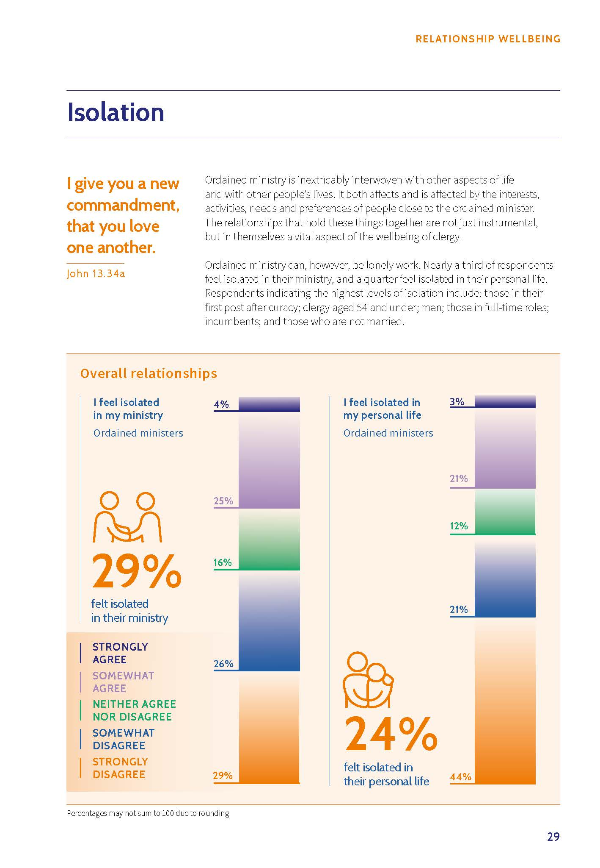
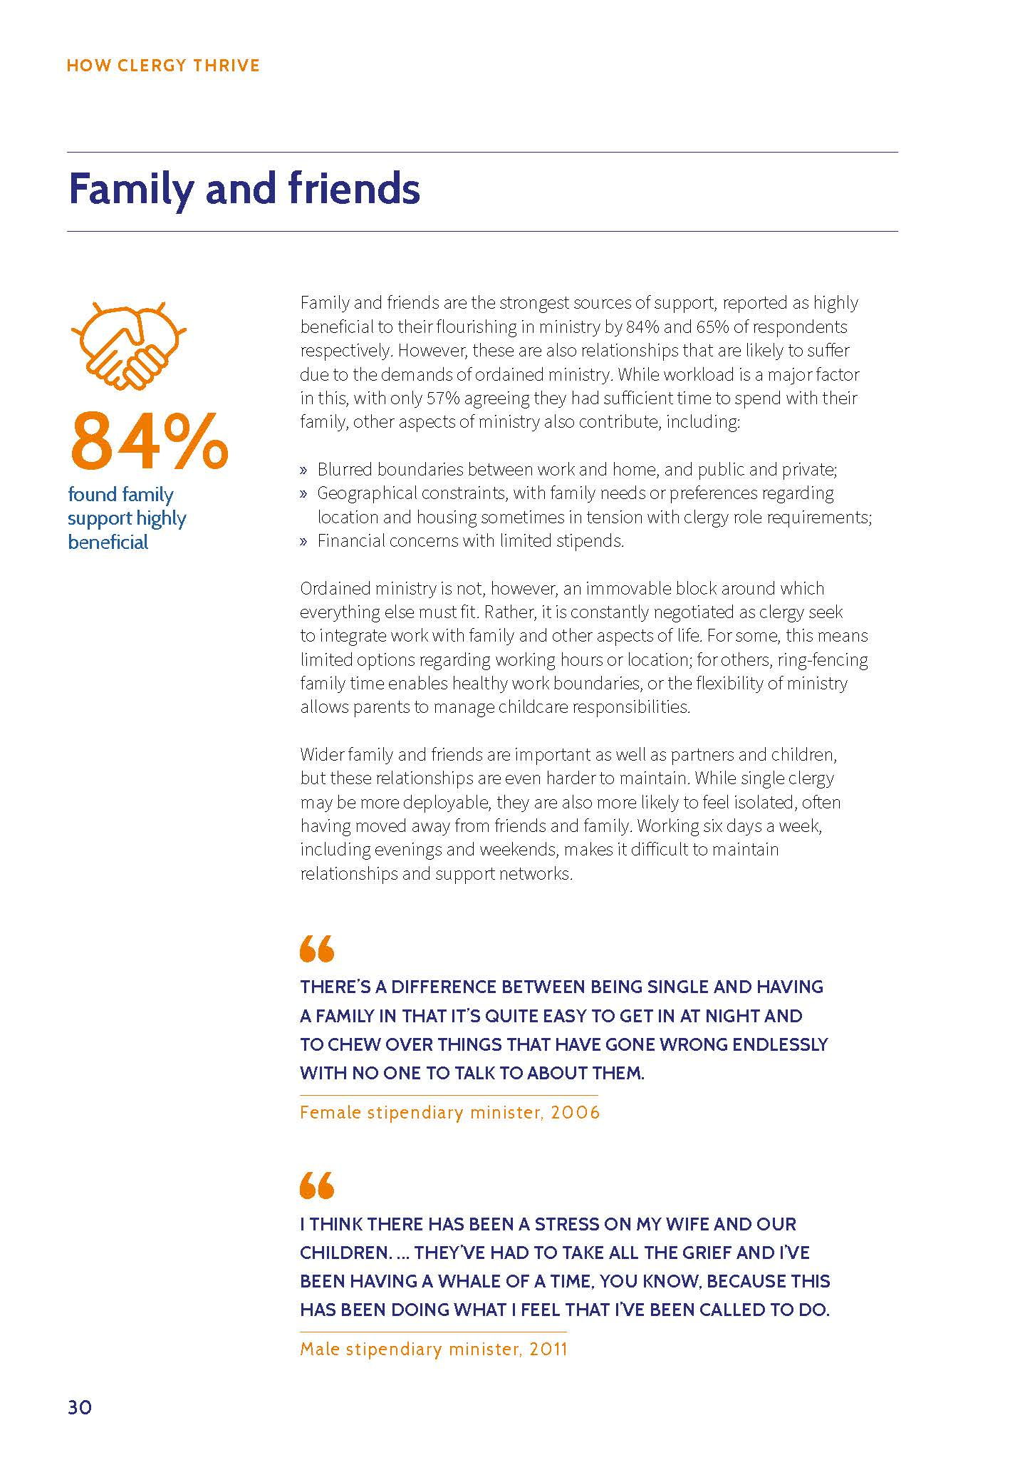

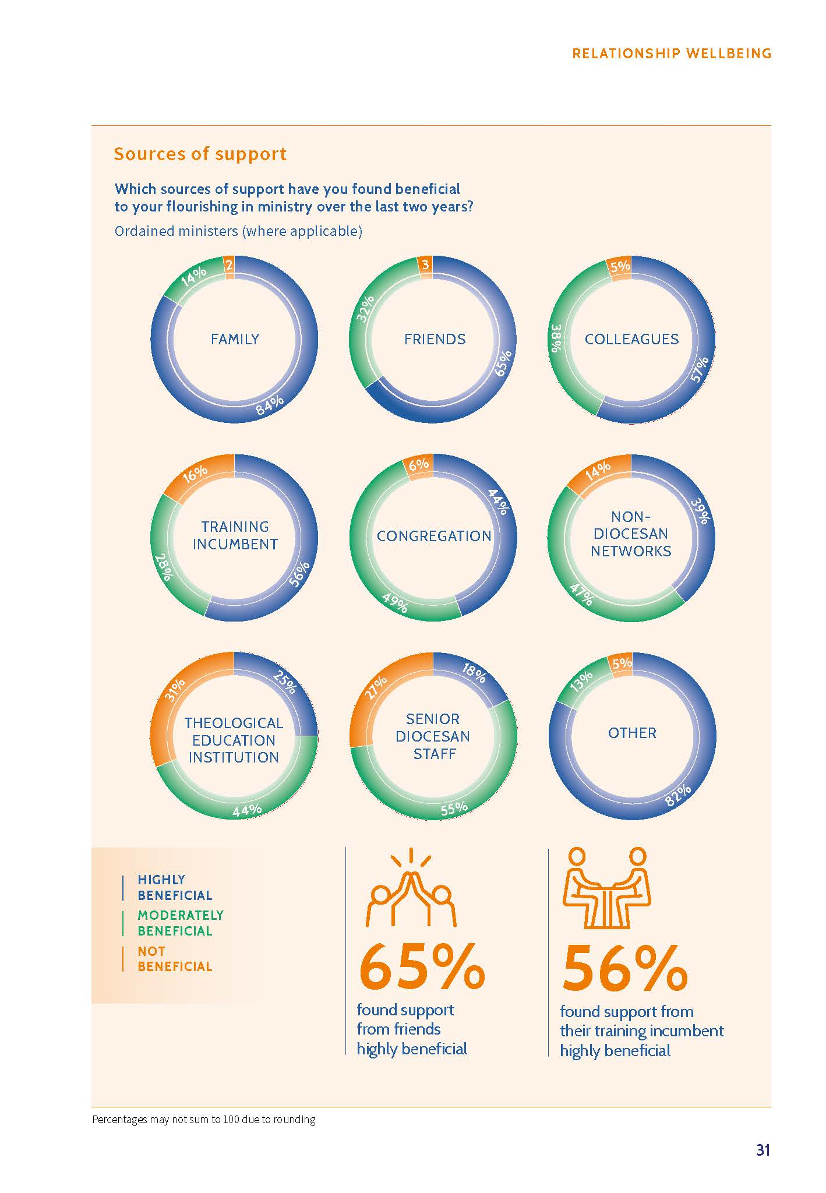
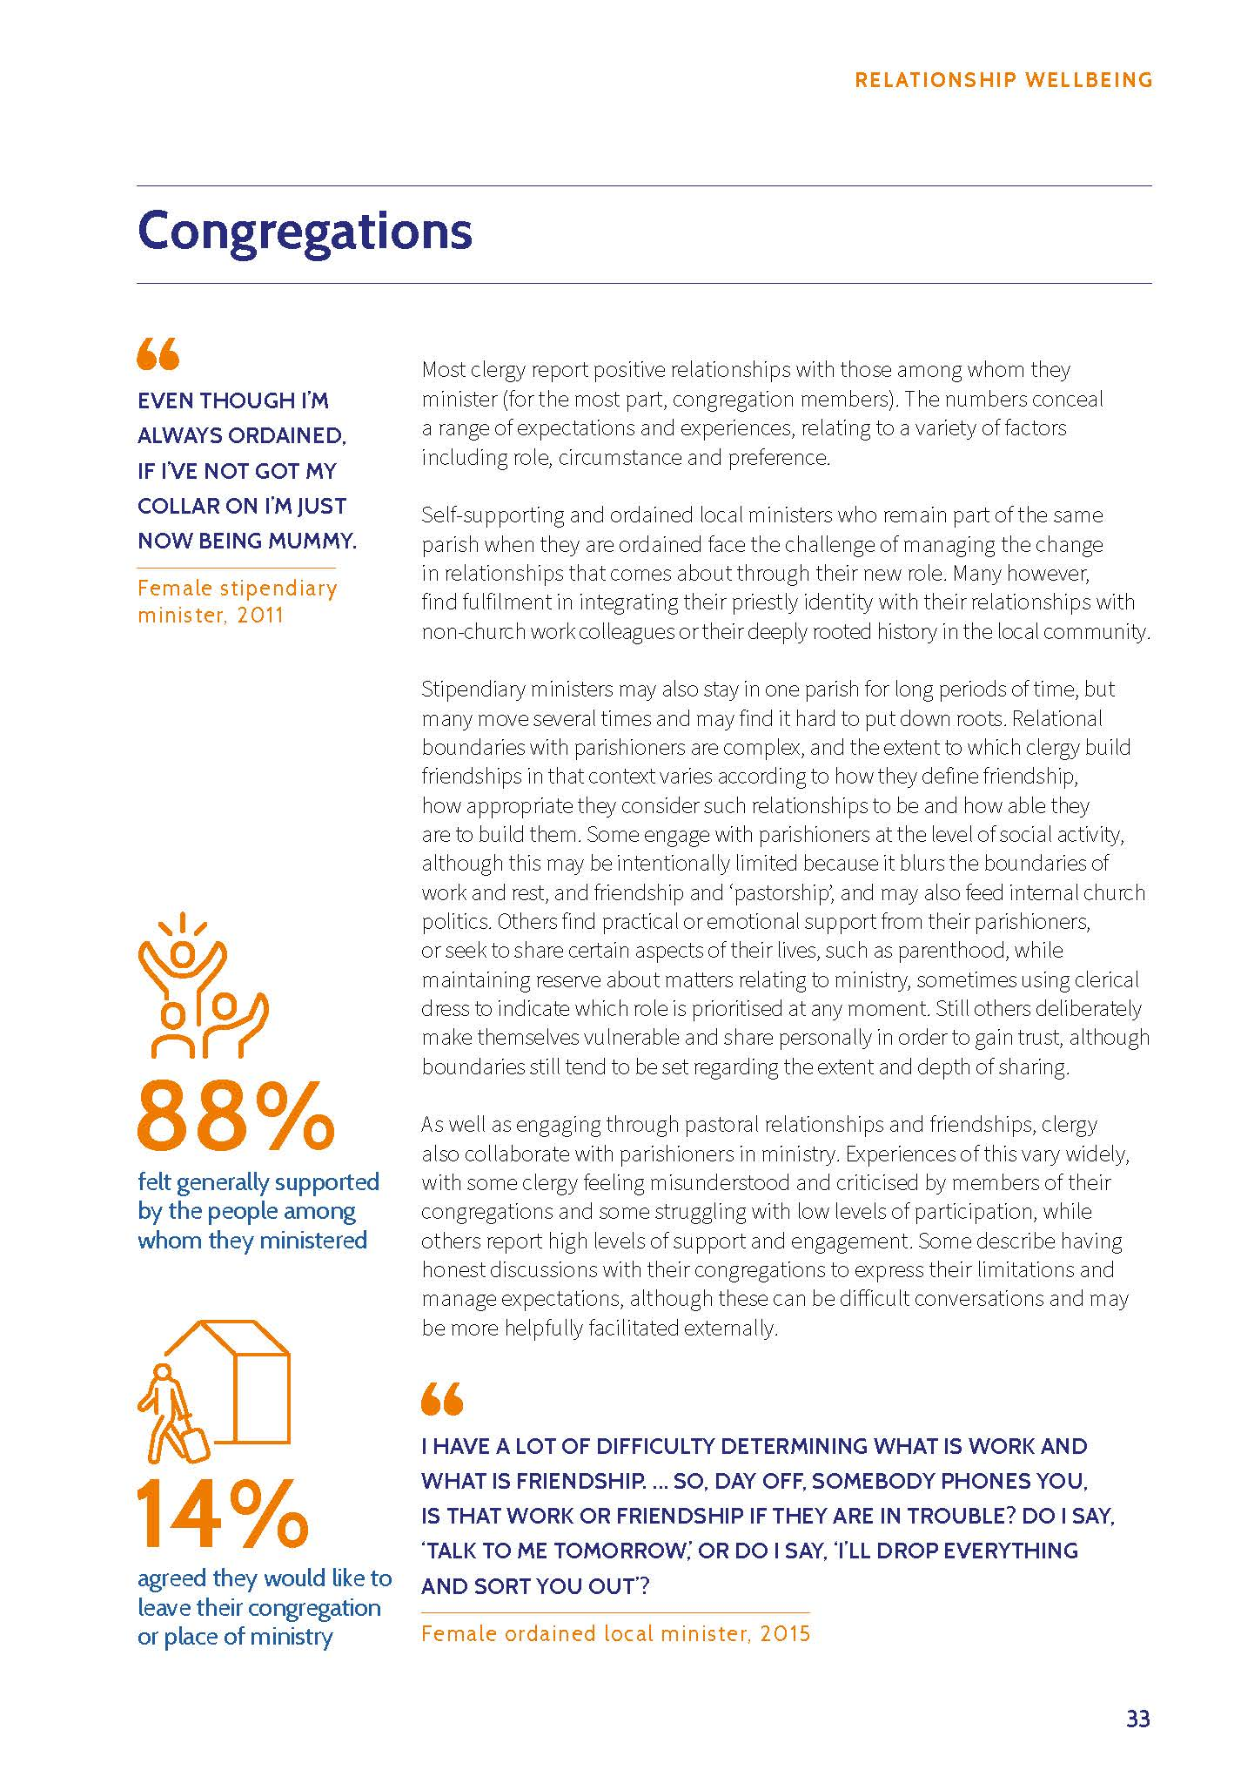

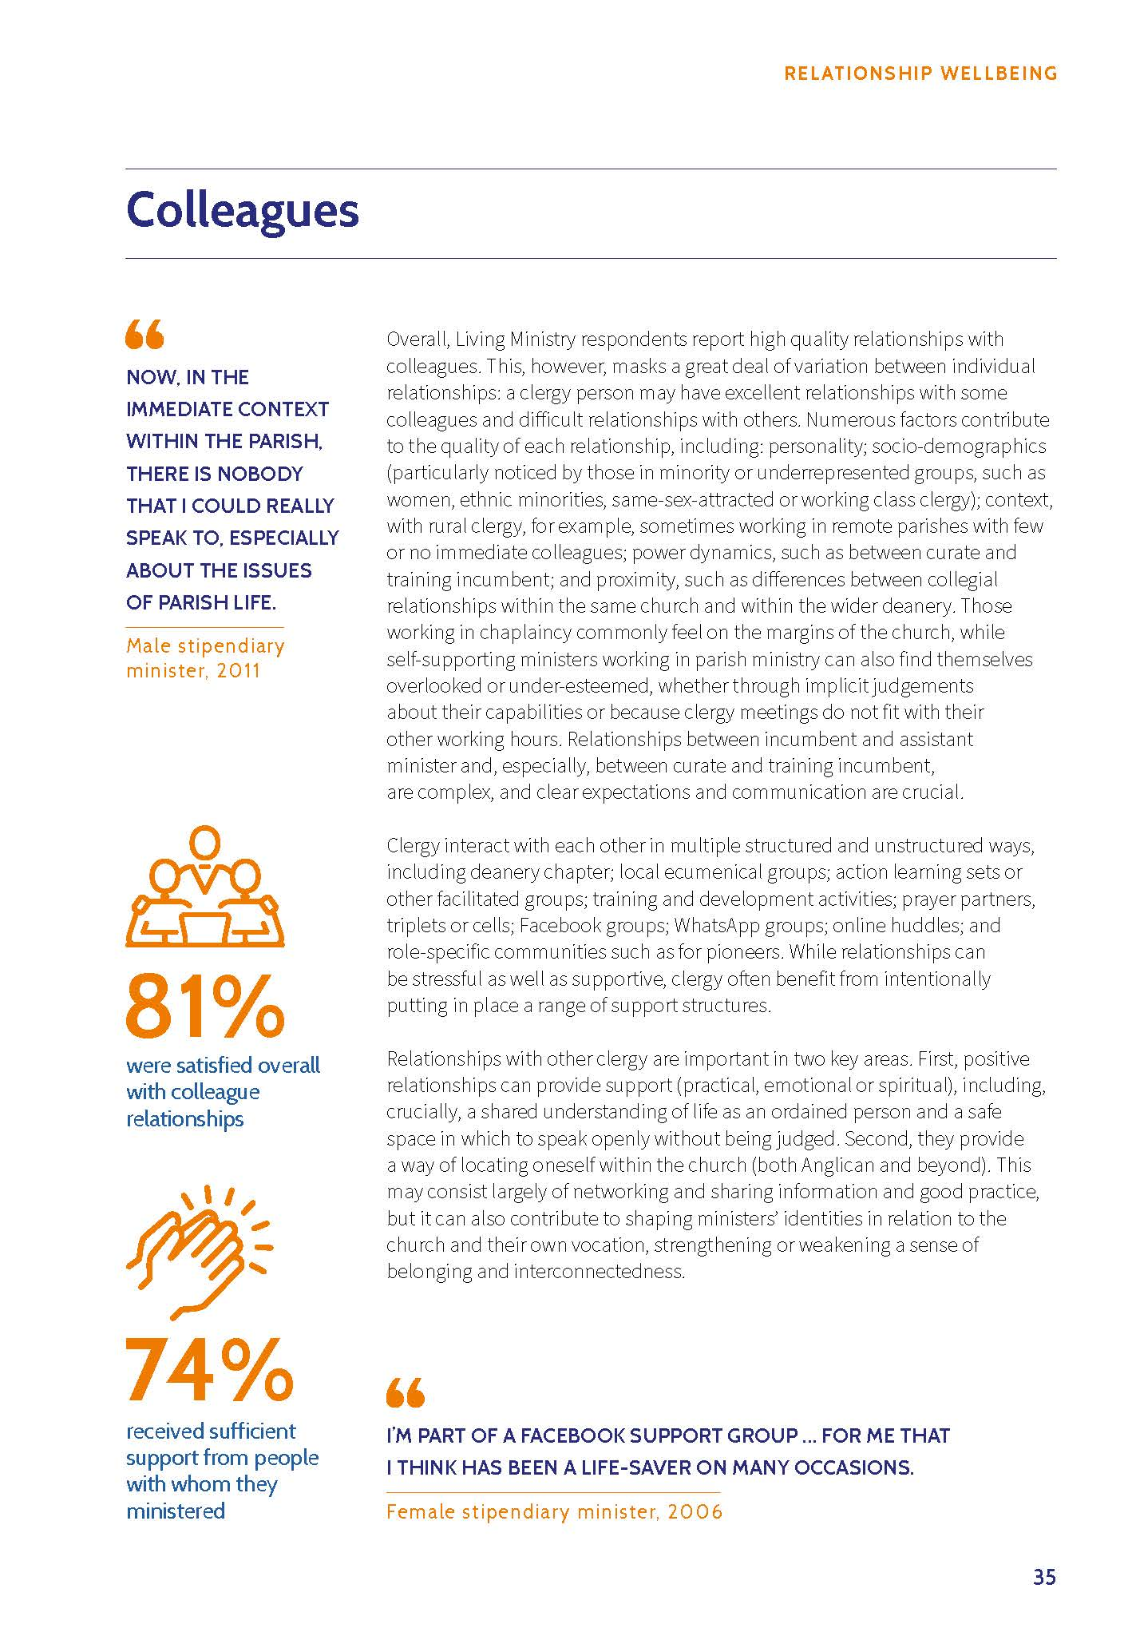

Case Studies
Introduction to the Case Studies
The following case studies form the basis of the program. This is a deliberate choice based on the recognition that ethical issues in ministry often require dealing with complex and difficult situations and people. The way we respond shapes our ministry and integrity.
Hence, the case studies are a construction of de-identified experiences, they draw on real life situations and therefore offer shades of grey. In each case considered, participants are invited to consider how they would respond in a similar situation.
The case studies reflect varying ministry situations and are written reflecting real-life issues and experiences of people within our Synod. Discussion questions are included at the end of each case study. The questions are generic so that they provide a framework for a lively and thoughtful conversation on the ethical questions in small groups.
All participants should read through the relevant sections of the Code of Ethics and Ministry Practice, Lay Leaders Code of Conduct and Lay Preachers Code of Ethics and Ministry practice.

Case Studies – Particular Relationships
Case Study 1 – School Chaplain
Rev Fiona is a Deacon and one of the Chaplains Hillview College, a Uniting Church School. It is a difficult start to the year with the other Chaplain position vacant. One of the year 10 students at the school, Harper, is the daughter of Fiona’s good friend from Theological College, Daniel who is minister at a local congregation.
Since she was in year seven Harper has felt comfortable coming to Fiona for advice and pastoral care as she navigated school concerns, friendship dramas, doubts about faith. At social catch-ups Daniel has commented how grateful he is that Fiona is able to offer this Pastoral Support outside of the congregation where he is minister. The Pastoral Care Team at Daniel’s church records Fiona as Harper’s pastoral carer.
During a Pastoral chat between Fiona and Harper. Harper brings up some family matters that are annoying her, standard teenaged fare. Fiona is uncomfortable during the conversation but doesn’t let on to Harper who clearly appreciates being able to talk with someone about these things. After the chat Fiona is reflecting and realizes that this is more than she wants to know about her friend Daniel’s home life and is wondering if she should continue the Pastoral Relationship with Harper.
Questions:
- Should Fiona continue the Pastoral Relationship? How might she ensure that Harper continues to receive Pastoral Care she needs
- Fiona decides to continue the Pastoral Relationship until a second Chaplain starts, which happens next term. Fiona passes Pastoral Care to the other Chaplain; however, Harper doesn’t like the new Chaplain. Daniel approaches Fiona and says it is her responsibility to ensure that Pastoral Care for Harper continues. Fiona thinks this is Daniel’s responsibility. Who is right? What might be the next steps for Fiona? for Daniel?
Case Study 2 – Pastoral Ministry and power dynamics between minister and spouse
사례연구: 목사와 목사 배우자 사이의 목회 사역 - 힘과 권한의 이슈
목사 A와 그의 배우자 B는 모두 같은 신학교에서 공부하였습니다. 결혼 후, A는 소속 교단에서 안수를 받고 교회에 임직하였으며, B는 동일한 교회의 회원이 되었습니다. B는 교회 의회와 재정 등 여러 사역에 적극적으로 참여하고 있습니다. 한 번은 격렬한 회의 후, 교회 의회 의장은 A에게 개인적으로 다가가서, A가 교회 공동체의 이익보다는 B의 입장을 지지했다고 지적하였습니다. A 는 B 가 교회 의회의 다른 의회원들과 마찬가지로 중요한 결정에 대해 동등한 영향을 미친다고 믿고 있습니다. 현재 A는 두 사람의 특별한 관계가 교회 사역에 미칠 영향을 우려하고 있으며, 이해충돌을 피하기 위해 사역 역할에 적절한 경계를 어떻게 설정할지 고민하고 있습니다.

질문들:
- A는 B와의 특별한 관계와 교회에서의 전문직 역할 사이에 어떻게 명확한 경계를 설정하고 두 역할이 존중받을 수 있도록 할 수 있을까요?
- A는 B가 그들의 결혼 관계의 영향을 받지 않고 교회 결정에 독립적으로 기여하도록 어떻게 격려할 수 있을까요?
- 유사한 상황을 경험한 적이 있다면, 문제를 어떻게 인식하고 해결책을 마련했는지 여러분의 소그룹 내에서 공유해 주세요.

Minister A and their spouse B both studied at the same seminary. After marriage, A was ordained by their denomination and appointed to a placement, while B became a member of the same church. B is actively involved in several ministries, including the church council and finance. After a heated meeting, the Chairperson of the Church Council privately confronted A, saying A had supported B’s position over the good of the Congregation. A believes B has the same influence on important decisions as any other member of the Church Council. A is now concerned about the impact of their particular relationship on the ministry and is considering how to maintain appropriate boundaries to avoid conflicts of interest.
Questions:
- How can A establish clear boundaries between the particular relationship with B and the professional role in the church, ensuring that both are respected?
- In what ways can A encourage B to contribute independently in church decision-making, without the influence of their marital relationship affecting the process?
- If you have experienced a similar situation, please share within your small group how you found the issue and provided solutions.
Case Study 3 – Family Relationships
Please note- Domestic and Family Violence is a huge issue and often Ministers will be dealing with both the one who uses violence against their intimate partner or family, and those who are experiencing it. The term Violence is used as it is a Violation of human rights.
Rev Magenta is relatively new to the placement and presbytery. He has a family with several children, one born just before the placement began. Rev Magenta has been in ministry for quite a few years.
One day at a gathering of ministers and their partners Rev Crimson is talking to Rev Magenta’s wife and they start to laugh. There is a noise and Rev Magenta, who is standing a few metres away talking to someone else, appears to be coughing. His wife looks up and freezes. She becomes very quiet.
Rev Magenta had given an ‘interesting’ look to his wife, then turned around and kept talking to those around him.
On another occasion Rev Crimson noticed something similar happen then later, walking past a different room they heard Rev Magenta telling their wife they were an embarrassment, and not humble or obedient enough for being a minister's wife.
Rev Crimson is concerned and decides to quietly make an appointment to see Rev Magenta, to see how they are settling in but also to gently test some of their concerns.
When Rev Crimson meets with Rev Magenta the conversation is going well, and it appears that the new placement is a good fit. However, when Rev Crimson asks whether it is working well for his wife and family, Rev Magenta speaks about how he has had a few issues and had to discipline his wife and children. Rev Crimson gets the impression this has happened before at the previous placement and may have resulted in a quicker end to that placement than otherwise.
Questions:
- What might ‘disciplining’ mean?
- What responsibilities does Rev Crimson have?
  - To Rev Magenta?
  - To Rev Magenta’s family?
- What does the Code of Ethics say to help inform the decisions or management of this situation?
- This situation includes children and Rev Crimson is a Mandatory Reporter, what other resources should Rev Crimson consider/consult.

Case Study 4 – Partner in the Middle
Rev Sarah has been in placement at Valley Springs Uniting Church for almost two years, bringing with her a fresh perspective and some changes to the traditional services. While many in the congregation appreciated her approach, a few members were resistant to the changes.
After a Sunday service, Jamie, Sarah's partner, was being served coffee by John, a congregation member who also serves on the Church Council. Instead of the usual pleasantries, John said, "Could you do me a favor? When you are in your marriage bed with Sarah tonight, let her know that some of us don't like her communion service and prefer the traditional service." Before Jamie could respond, the next person in line for coffee started a conversation with John.
Later that day, over lunch, Jamie tells Sarah about the conversation. Jamie is upset as they try to avoid church conflicts. Sarah is furious. While John has previously used other people to convey his messages instead of talking directly to her, this is a new low.
Questions:
- What boundaries need to be established, by whom?
- At a social gathering the Chair of Church Council finds out about the exchange from Jamie. The Chair pulls Sarah aside and is also angry at what transpired, offering to Sarah to do something about it with the Church Council. What are healthy ways Sarah can respond.
- Whilst Jamie is upset and needs Pastoral Care, they don’t want to bother other busy ministers so decline Sarah’s offer to find outside Pastoral Care. How might Sarah navigate this?
Case Study 5 – Parent in Aged Care
Pastor Sione is a Chaplain at Apple Grove Residential Aged Care Facility Minister where Margaret, mother of Reverend Duncan, is a resident at the facility. Reverend Duncan was deeply concerned about the treatment plan for their mother and felt that the nursing staff were not addressing his concerns adequately. Despite raising these issues with the nursing staff, the Reverend Duncan remained unsatisfied and frustrated.
Seeking assistance, the Duncan approached Sione, who listened attentively to their concerns, careful not to undermine the nursing staff, and explained the next steps Duncan could take within the facility if they wished to escalate the issue further. Following the conversation and unbeknownst to Duncan, Sione conducted private enquiries and was informed that the nursing staff were following Margaret's own wishes for her care rather than instructions from family. This confirmed for Sione his decision to not engage further.
In a later conversation Rev Duncan, however, was not satisfied that Sione would only listen, not get involved. Expressing their frustration, Duncan declared that if Sione could not help, they would find someone who could. "I am an ordained minister of the Church, and this is a Church facility, they cannot ignore me!" True to their word, Rev Duncan contacted the Moderator, cc’ing Sione, requesting intervention and blaming Sione for not acting.
This escalation led to the facility manager approaching Sione with questions. The manager was concerned about why people in leadership in the organisation and the church were now involved in an individual treatment plan and the out of proportion escalation of matters. This situation has put the facility manager and nursing staff on edge.
Questions:
- What are the pastoral responses for Sione?
- Did Rev Duncan overstep in using his position?
- What advice would you give to Pastor Sione for future engagements with Reverend Duncan?

Case Study 6 – Family involvement
Scott has recently been Commissioned as Pastor at Riverbend Uniting Church (a regional church), where his family have been members for the last 20 years. He is happy to step into the role and embrace the new opportunities that now exist, which were not available when he led in a volunteer capacity.
His daughter, Chloe, has recently returned to town with a new work-from-home job following her time in university studying finance. During her time at university, Chloe was involved in a university church and held some leadership roles including serving as Assistant Treasurer.
The Riverbend Church Council treasurer, who has been looking to step down for a while, announces to the congregation he is finishing up as Treasurer and suggests that Chloe would make a great replacement. After the service multiple people ask Chloe if she will do it, to which she says “No, I don’t have the time.”
Scott is now receiving a lot of pressure to get Chloe to change her mind, at least in the short term, as Riverbend Uniting Church will soon be without a Treasurer. Scott knows that if congregation members keep pressuring Chloe, she will simply stop coming to Church.
Questions:
- How might Scott manage establishing boundaries for his family? How should Scott respond when those boundaries are tested?
- Scott had made arrangements for an elder in the congregation to continue the Pastoral Care role of Chloe before she left for university. Following the pressure to become Treasurer Chloe no longer wants Pastoral Care from the Elder. How might Scott ensure Chloe continues to receive Pastoral Care?
- “There is no gift without its corresponding service” How might Scott still encourage Chloe to use her gifts and skills to serve, in a way that is consistent with what she wants and her life stage?

Paired Sharing
The facilitator of the training will make a decision about the paired sharing process. This may take place at this point, or individually after the formal end of the session, particularly if the training is taking place in an online setting, or with a small group where paired sharing may be difficult to manage. The guidelines for paired sharing are towards the beginning of this document.
Close of Session
Thank you for your participation in these discussions. If any issues have been raised for you, ensure you talk with your supervisor about them.

