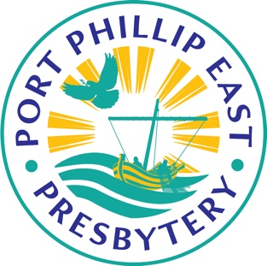
Port Phillip East Presbytery
Election of Office bearers 2022
Nomination Form

NAME . . . . . . . . . . . . . . . . . . . . . . . . . . . . . . . SIGNATURE . . . . . . . . . . . . . . . . . . . . . . . . .
is nominated for the position of
Deputy Chairperson of Presbytery
Committee Member, Standing Committee
NOMINATED BY
NAME. . . . . . . . . . . . . . . . . . . . . . . . . . . . . . . . . . .SIGNATURE . . . . . . . . . . . . . . . . . . . . . . . . . . . .

Please attach a (separate) photograph and a maximum 500-word statement from the nominee relating to membership of the Uniting Church, understanding of the role, and ability to engage with the tasks and capacity outlined in the position description. See the attached nomination template.

NOTES
One form should be used for each person nominated. The form allows for the person to be nominated for more than one position. Please scan or photocopy extra copies for other people. Electronic versions available from Presbytery Secretary Anne Kim. Electronic nominations are preferred.
Nomination forms must be submitted to Anne Kim, secretary@ucappep.org or PO Box 696, Noble Park, VIC 3174, by 5.00pm Friday, March 5, 2021. Nominations will be shared with the Presbytery a week before the Presbytery meeting on Saturday March 19.
Port Phillip East Presbytery
Election of Office bearers 2022
Personal Profile
UCA Membership
Write up to 150 words on your involvement with the Uniting Church, including your membership of the UCA.

Understanding of the Role
Write up to 150 words on your understanding of the role and how you see yourself fulfilling the tasks.

Capacity
Write up to 200 words on your experience, God-given abilities and availability that would contribute to the role.

